Book: Learn about china with Ping- Pong, the Panda Bear
- Vocabulary
No copie el número, solo la expresión en ingles y encuéntrele el significado acorde a la lectura

climb trees  1 | rooster  15 | streets  29 | were dressed  43
leaf / leaves  2 | land size  16 | bright  30 | silver  44
twigs  3 | third  17 | plow (s)  31 | hat (s)  45
woddy plant  4 | largest  18 | field  32 | string  46
grow (s)  5 | country  19 | bring  33 | remind  47
very fast  6 | anywhere else  20 | waved  34 | kisses  48
begin (s)  7 | Great Wall  21 | gentle  35 | blew /blow  49
you will learn  8 | longest  22 | slow  36 | laugh / laughed  50
new things  9 | build /built  23 | move (s)  37
said  10 | wiggles  24 | ago  38
lucky number  11 | look like  25 | shadow  39
I am ready  12 | bites  26 | puppet  40
shout / shouted  13 | shop  27 | heard  41
shape/ shaped  14 | busy  28 | giggling  42

- Questions
Responda con la opción correcta, según la lectura
1.Panda is:  a)A bird  b)A bear  c)A rooster | 2.Who is Ping Pong  a)a father bear  b)a mother bear  c)a son bear | 3.Ting is  a)Panda’s moom  b)Panda’s brother  c)Panda’s dad
4.The Great Wall of China is  a)very lon  b)very short  c)very long | 5.Does China have big cities?  a) yes, it is  b) yes, it does  c)yes, it do | 6.China has  a) a lot of people  b) a lot of land  c) a lot of coffee
7.What sport is Ping Pong practicing?  a) soccer  b)tennis  c) Kung fu | 8. Children from China, normally  a) go to school, read and drink coffee  b)go to school, shout, and built the Great Wall  c)go to school, play and blow kisses
10. China is shaped like  a) 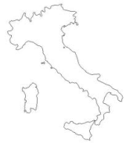  b) 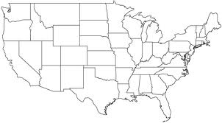  c) 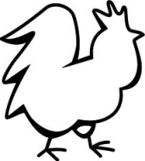 | 11. The flag of china is  a) 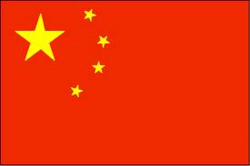  b) 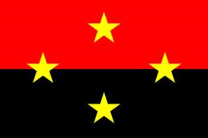  c) 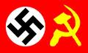

12. There are things that identify the countries. Make 3 drawings for each country
- Colombia
- The United Stated
- China
- Canada

