BOOK 5: I SCREAM FOR ICE SCREAM
1. VOCABULARY
Write the meaning of the following words and expressions
scream | ready | now I can choose my toppings
ice cream | sprinkles | good job
yummy | gummy bears | everybody is happy
sundaes | bowls | making your own ice cream
gather | carefully | I also love whipped
need | our favorite candy | all of my friends are coming over
chocolate sauce | I grab a spoon | I take a big bite

2. QUESTIONS
Read the book and then answer the following questions

- Do you like the ice cream?
A. Yes, I does
B. Yes, I do
C. Yes, I like

- A spoon is
A. | B | 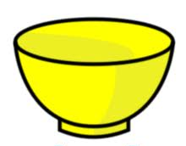C

- The writer for the book “ I scream for ice cream” was
- A father
- A teacher
- A student

- The nationality for the book writer is…
- English
- Colombian
- American

- Yummy is…
- Very nice (taste)
- Very bad (taste)
- Sour (taste)

- To make ice cream we need (according to the story)
- Crisps, bananas and caramel sauce
- Gummy bears and our favorite candy
- Ice cream, rice and milk

- In this cone ice cream, the cherry is…
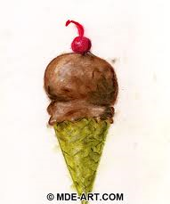
A. on the top of the cream
B. on the left of the cream
C. on the right of the cream

- The best description to the following image is

- Everybody is sad
- Everybody is hungry
- Everybody is happy

