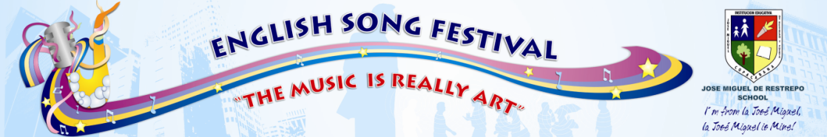
CONGRATULATIONS TO THE WINNERS AND OUR PARTICIPANTS IN THIS GREAT FINAL!
WINNERS
SOLOIST
PLACE | SINGER | SONG | COURSE | FINAL SCORE
1st | MARIA ALEJANDRA LINARES | HALO BY BEYONCE | 11-4 | 63%
2nd | YANCELY HERNANDEZ | THE CLIMB BY MILEY CIRUS | 9-2 | 45%
3rd | SARA LONDOÑO | YOU BELONG WITH ME BY TAYLOR SWIFT | 9-1 | 43%

DUET
PLACE | SINGERS | SONG | COURSE | FINAL SCORE
1st | THE TRUTH FACE (SARA BUETO AN DANIEL TOBON) | GET RIGHT BY JENNIFER LOPEZ | 10-01 | 100%
2nd | Y-O (YANCELY HERNANDEZ AND OSCAR GOMEZ) | WHAT I HAVE BEEN LOOKING BY HIGH SCHOOL MUSICAL | 9-2 | 77,5%
3rd | THE PRINCESS GIRLS (VALENTINA GUZMAN AND SARA ZAPATA) | PLEASE DON´T STOP THE MUSIC BY RIHANNA | 7-6 | 70%

GROUP
PLACE | SINGERS | SONG | COURSE | FINAL SCORE
1st | IT IS ON | IT IS ON BY CAMP ROCK TWO | 7-1 | 85%
2nd | THE PERFECT FLOW | BAD ROMANCE BY LADY GAGA | 8-1 | 57,5%
3rd | AMERICAN LEMON | LEMON TREE | 8-5 | 35%

JURIORS: JUAN PABLO RODRIGUEZ CARLOS M. ALVAREZ
ENGLISH TEACHERS FROM THE WORLD SCHOOL OF THE ENGLISH LANGUAGE

