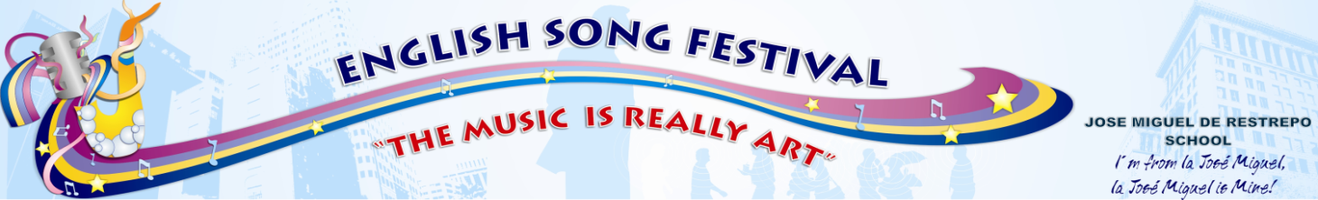
PROGRAM
NOVEMBER, 2ND 2010
FIRST PERFORMANCE: 10.00 AM TO 12.00 PM
SECOND PERFORMANCE: 2.00 TO 4.00 PM

SPEECHS BY LUIS BERNARDO CASTAÑO ZULUAGA AND COORDINATORS.
ANTHEM OF THE SCHOOL

OPENING FESTIVAL BY ENGLISH TEACHERS
INTRODUCING OUR FESTIVAL
LIC. CARLOS ALVARADO
LIC. JAMES GALLEGO
LIC. NELLY GIRALDO
JURIES: Juan Pablo Rodriguez and Carlos M. Alvarez from the World School of the English Language.

1. YOU BELONG WITH ME BY SARA LONDOÑO
CATEGORY: SOLOIST COURSE: 9-1
2. THE CLIMB BY YANCELI HERNANDEZ.
CATEGORY: SOLOIST COURSE: 9-2
3. LEMON TREE BY AMERICAN LEMONS
CATEGORY: GROUP COURSE: 8-5
4. HALLO BY MARIA ALEJANDRA LINARES
CATEGORY: SOLOIST COURSE: 11-4
5. STAY MY BABY BY THE NICE GIRLS
(ANDREA BEDOYA AND ALEJANDRA CANO)
CATEGORY: DUET COURSE: 8-5
6. IT´S ON BY IT IS
CATEGORY: GROUP COURSE: 7-1
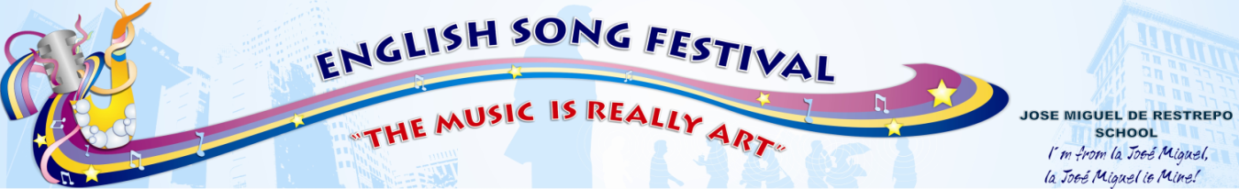

- INTERLUDE: LA ISLA BONITA BY PRIMARY´S STUDENTS
7. PLEASE DON´T STOP THE MUSIC BY THE PRINCESS GIRLS
(SARA ZAPATA AND VALENTINA GUZMAN)
CATEGORY: DUET COURSE: 7-6
8. BABY BY SUPERSTARS
CATEGORY: GROUP COURSE: 8-3
9. SWEET CHILD O MINE BY DIEGO PINO
CATEGORY: SOLOIST COURSE: 7-2
- INTERLUDE: GOTTA GO MY OWN WAY BY CAMILO PUERTA
10. BAD ROMANCE BY THE PERFECT FLOW
CATEGORY: GROUP COURSE: 8-1
11. GET RIGHT BY THE TRUTH FACE
(SARA BUETO AND DANIEL TOBÓN)
CATEGORY: DUET COURSE: 10-1
12. WHAT I HAVE BEEN LOOKING BY YEI- OU
(YANCELI HERNANDEZ AND OSCAR GOMEZ)
CATEGORY: DUET COURSE: 9-2
- INTERLUDE: NATURALLY BY LAURA ARISTIZABAL AND DANIELA RESTREPO
13. RESULTS
14. AWARDING OF PRIZES (CATEGORIES: SOLOIST, DUETS AND GROUPS)

NOTA: PROGRAMACIÓN QUE PUEDE SER SUJETA A MODIFICACIONES Y EN CASO DE EVENTUALIDAD SE COMUNICARÁ A LOS DIRECTIVOS, DOCENTES Y ESTUDIANTES POR INTERMEDIO DE LOS INTEGRANTES DEL COMITÉ CENTRAL O EN EL WEBSITE : http://englishconexionambiente.jimdo.com

