Let’s go to the zoo

Let’s go to the zoo
It’s big, it’s great
Let’s go to the zoo
And have a lemonade

Where’s the lion?
Where are the dolphins?
Where’s the monkey?
I like the dolphins
Do you like the dolphins?

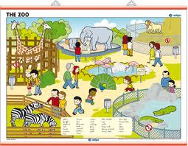
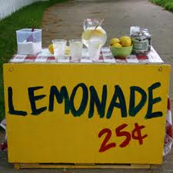
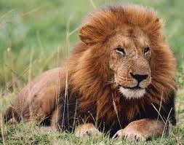
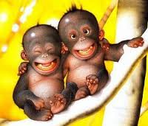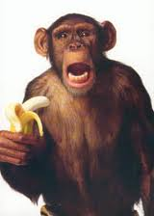
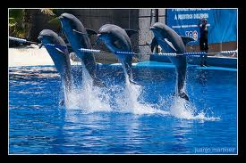
ACTIVITY - IN TEAMS
Make a parody including environmental topic

