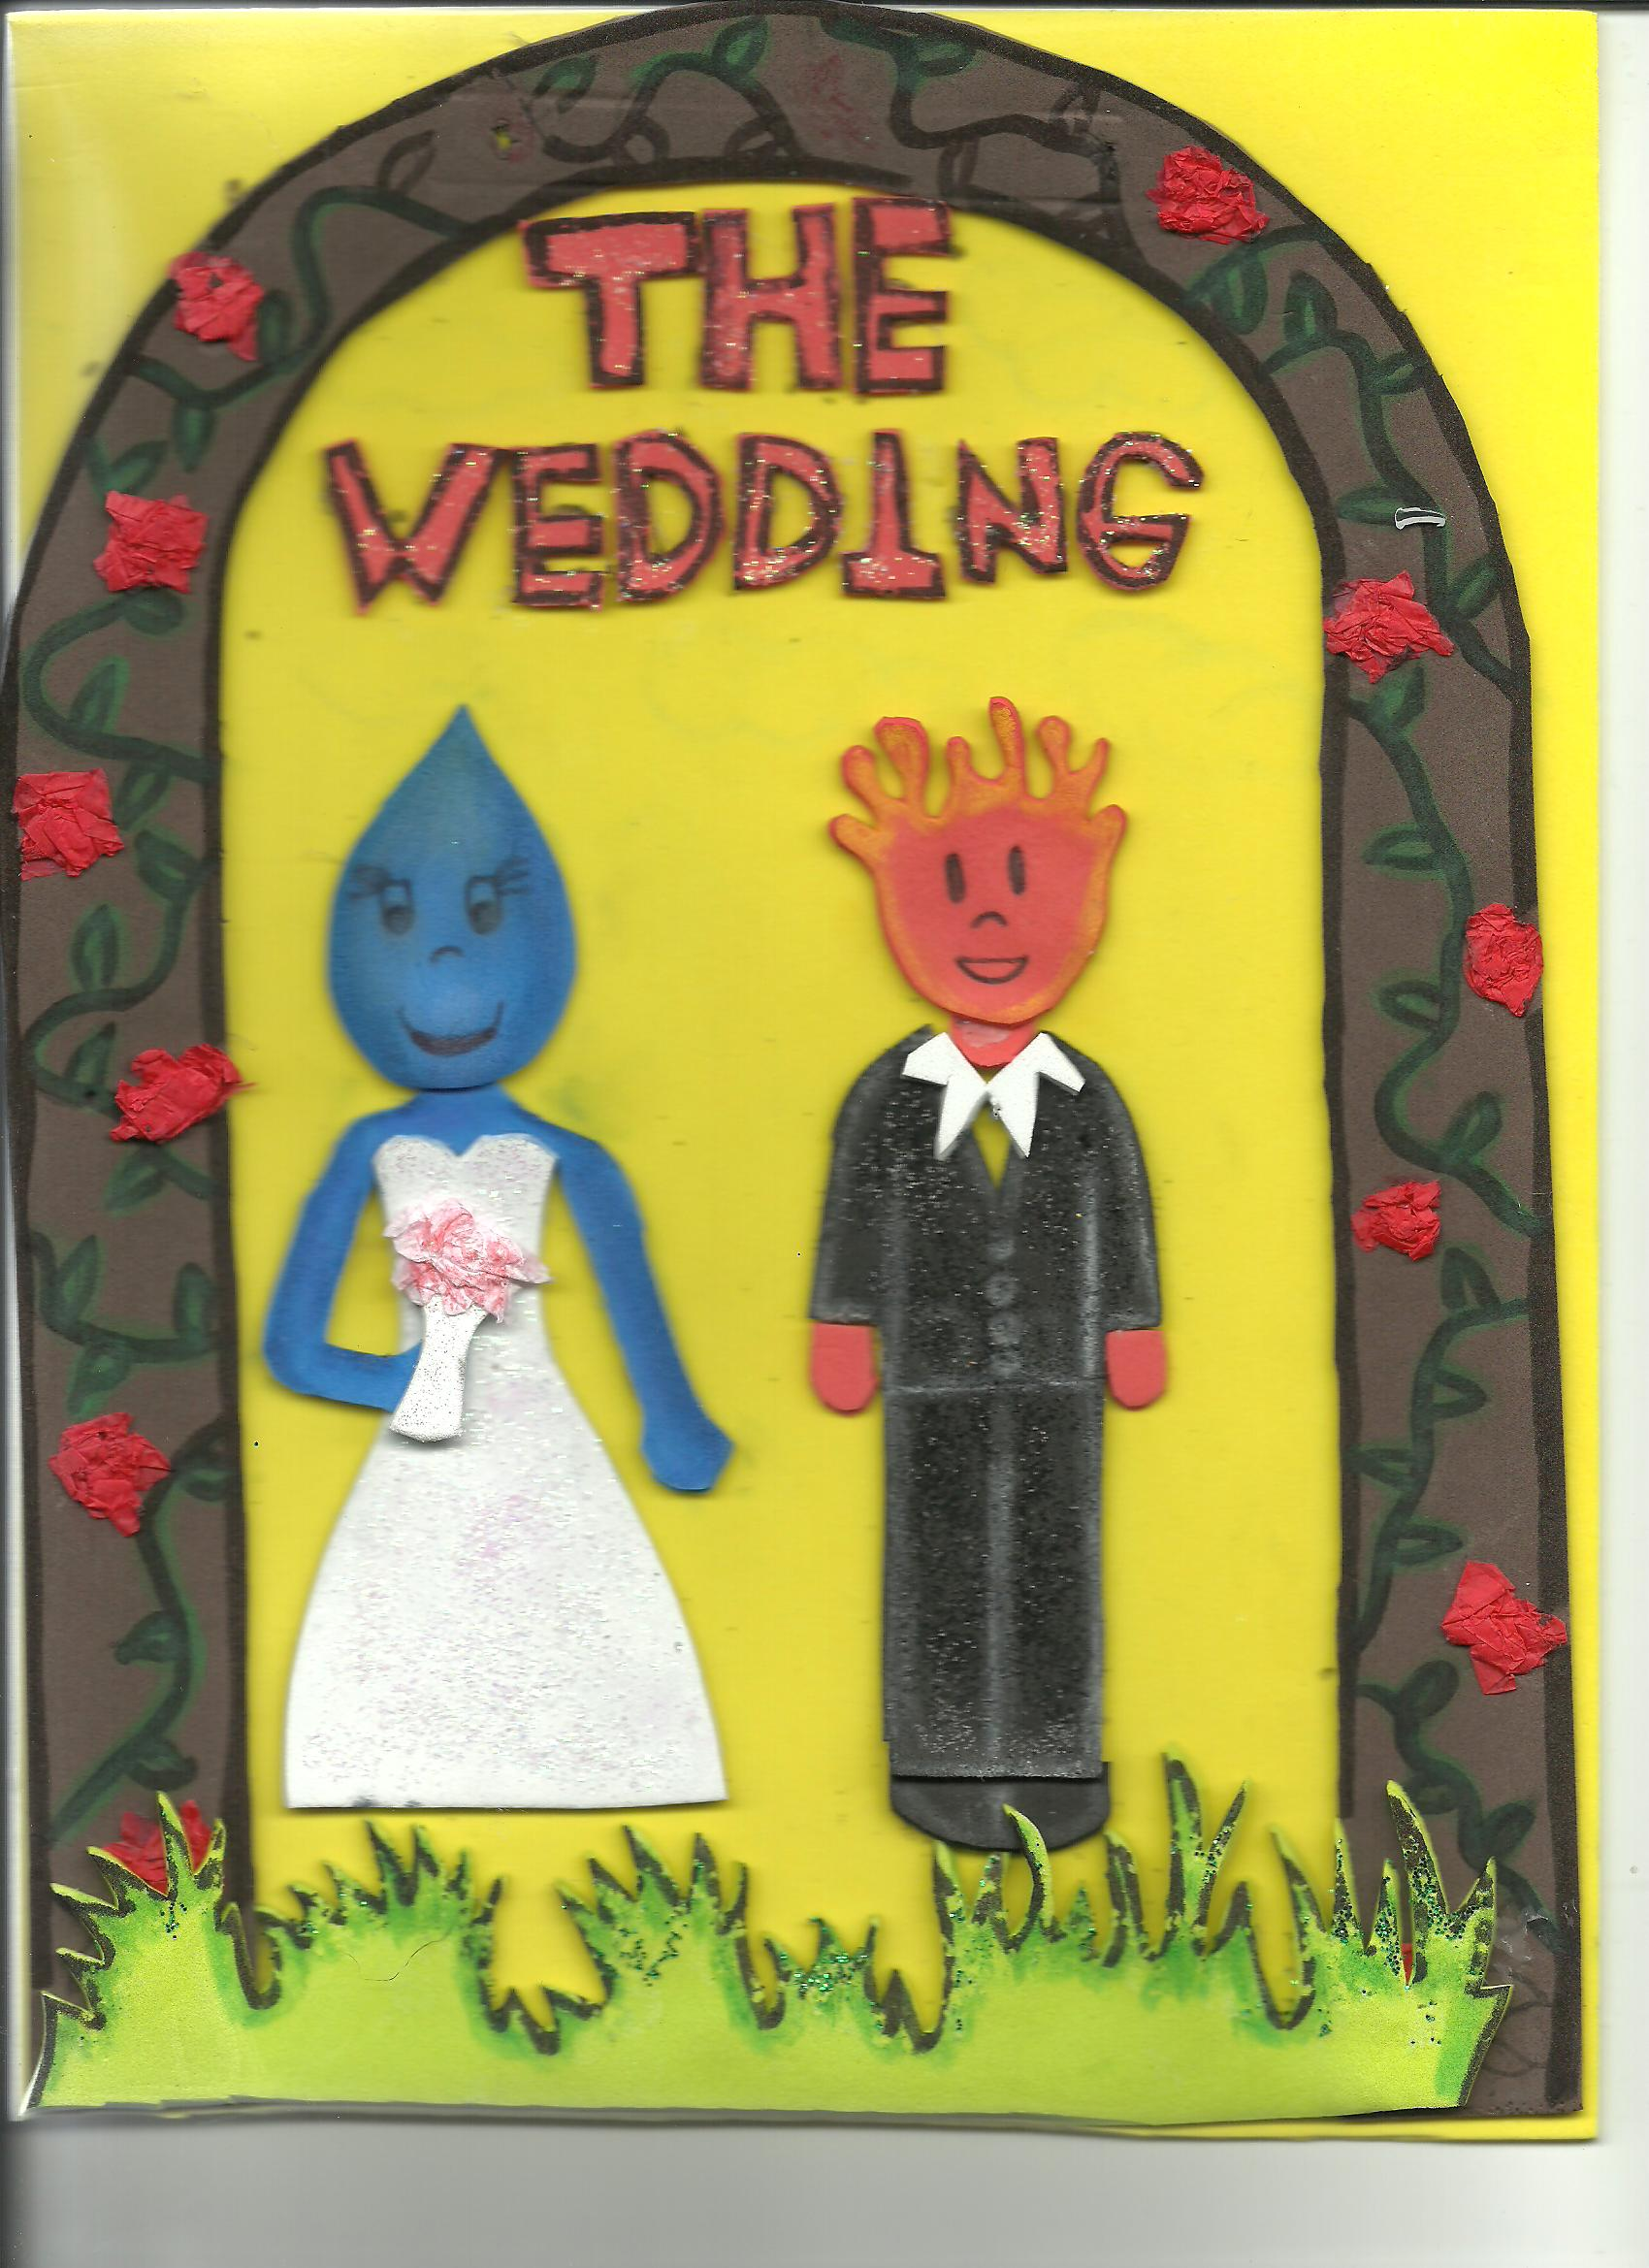
The wedding was at 7:00 pm. The bride wore a long white dress. The groom wore a black suit. He was very elegant.
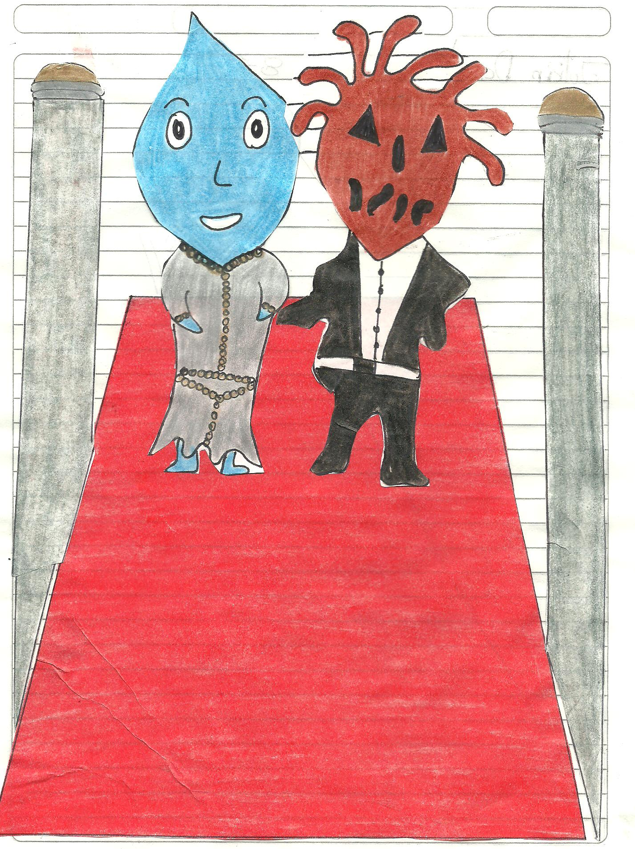

The wedding was at noon. The groom wore a black suit. The bride wore gray dress with belt. She was a little scared.

