Comparative – Superlative
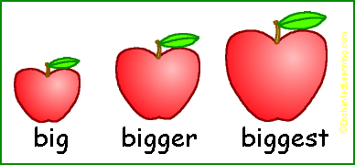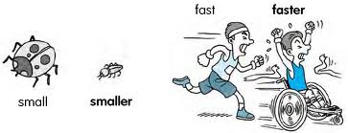

- Old - young - small - big - fast - slow
http://www.hshc.de/unterricht/comparison/comparison2.htm
- The pet and the family : http://s.mound.free.fr/skyblues67/comparing/trig&family1.htm
- Write the comparative to make sentences (with drawings )
http://www.montsemorales.com/gramatica/Comparative2.htm
- video explanation- comparative: http://smrtvideolessons.com/2013/07/09/comparative-adjectives-part-1/#sthash.r5RzER2u.dpbs
- comparative –superlative test
http://www.ihbristol.com/free-english-exercises/test/esol-smc-comparatives-superlatives
- as… as explanation: http://www.azargrammar.com/assets/intermediate/FEGiGrammarSpeaks/chapter9/feg_ca_09_001.swf
- type the superlative (drawings) http://jerome.boulinguez.free.fr/english/file/hotpotatoes/superlatifs2.htm
- Gap fill . superlatives: http://jerome.boulinguez.free.fr/english/file/hotpotatoes/superlatives.htm
